**SHAABAN ROBERT SECONDARY SCHOOL**

**BIOLOGY DEPARTMENT**

**FORM THREE**

**COURSE OUTLINES**

1. **CLASSIFICATION OF LIVINGTHINGS.**

* Kingdom Plantae

Division Coniferophyta (Conifers)

Division Angiospermophyta (Flowering Plants/Angiosperms).

1. **MOVEMENT.**

* The concepts of Movement and Locomotion
* Movement in Animals

Movement of Human body

The Human skeletal system

Muscles and Movement.

* Movement in Plants.

The concepts of Movement of Curvature.

1. **CO-ORDINATION.**

* The Concepts of Coordination
* Coordination in Animals

Nervous Coordination in Human

Sensory Organs

Drugs and Drug Abuse in Relation to Nervous Coordination

Hormonal Coordination in Human (The Endocrine System).

* Coordination in Plants

The Concepts of Tropic and Nastic Responses.

1. **EXCRETION.**

* The Concepts of Excretion
* Excretion in Human
* Complications and Disorders of Excretory System.
* Excretion in Plants.

1. **REGULATION.**

* The Concepts of Regulation.
* Types of Regulations

Temperature Regulation in Animals/Mammals

Osmoregulation in Mammals

Blood Sugar Regulation in Mammals.

1. **REPRODUCTION.**

* The Concepts of Reproduction
* Meiosis and Reproduction
* Reproduction in Flowering Plants

The structure of the flower

Pollination and Fertilization

* Reproduction in Mammals

Gamete Formation and Fertilization

Multiple Pregnancies

* Disorders of Reproductive System
* Complication of the Reproductive System
* Sexuality and Sexual Health and Responsible Sexual Behavior
* Family Planning and Contraception
* Maternal and Child Care.

**GROWTH AND DEVELOPMENT.**

***Meaning of Growth:***

Growth is a permanent increase in size and dry mass/weight of an organism.

The growth process is not a steady one; sometimes growth occurs rapidly, at other times slowly. Individual patterns of growth vary widely because of differences in heredity and environment.

Growth can be either ***negative*** or ***positive***

***Positive growth*** occurs when the rate of cell increase is higher than the rate of cell loss.

***Negative growth*** occurs when the rate of cell increase is lower than the rate of cell loss.

**Note:**

Growth in multicellular organisms occur as a result of:

* ***Assimilation***. The absorption of nutrients followed by utilization to form new protoplasm.
* ***Cell division***. That is, formation of new cells from the pre-existing cells. This results in an increase in number of cells.
* ***Cell expansion***. The cell increase in size when it absorbs water by osmosis especially in plants where cells takes in water into their vacuoles and expand.
* ***Cell differentiation***. This is when various cells are specialized for performing different functions
* ***Cell elongation***. That is, permanent increase in size of a cell due to increase in protoplasm.

*What is the difference between growth and development in living organisms?*

Development is a change in structure and complexity of an organism.

It involves cell differentiation and formation of various tissues and organs that perform specific functions.

*Growth* is ***quantitative***, that is, it can be measured by weight, volume and mass *while development* is ***qualitative***, that is, it cannot be measured.

The two processes (growth and development) occurs together. That is, growth is accompanied by development.

***Importance of Growth***

1. Helps to repair the old or damaged cells of the body.
2. It helps to adapt the organism to its environment due to cell differentiation.
3. It leads to maturation of reproductive organs which affects perpetuation of the species.
4. Enable increase in size and weight of the body of an organism.
5. It gives rise to a more complex and elaborate multicellular organism.
6. It gives rise to various cells specialized for various functions. E.g. red blood cells, white blood cells, palisade cells, guard cells, xylem, phloem, etc.

***Types of Growth***

There are several types of growth which includes:

1. Diffuse growth
2. Localized growth
3. Allometric growth
4. Isometric growth
5. Intermittent growth
6. Determinate growth
7. Indeterminate growth

* ***Diffuse growth*** is a type of growth whereby growth occurs in *all parts of the body* of an organism. E.g. in animals
* ***Localized growth*** is a type of growth in which growth takes place in specific regions of an organism. E.g. primary growth takes place at the root tips and shoot tips only.
* ***Allometric growth*** is a type of growth whereby *different parts of the body of an organism grow at different rates and stop growing at different time*. E.g. in human, brain grow faster initially than other organs then stops while the rest of the body continue to grow. In plants, flowers grow faster than the vegetative parts.
* ***Isometric growth*** is the type of growth whereby all body organs grow at the same rate. E.g. in fish, locust, etc.
* ***Intermittent growth*** is the type of growth in arthropods in which growth takes place in a series of stages called instars. E.g. in grasshoppers, housefly, cockroach, etc.
* ***Determinate growth*** is the type of growth in which an organism stop growing when a certain body size or age is attained. E.g. in mammals, birds and annual plants.
* ***Indeterminate growth*** is the type of growth in which an organism do not stop growing. E.g. perennial plants, shrubs, fish and reptiles

***Measurement of Growth***

Growth can be measured by:

1. Total fresh weight
2. Volume
3. Length
4. Number
5. Dry weight/mass

* ***Total Fresh Weight:*** this method involves weighing the whole organism at regular intervals. The method does not involve injury to the organisms. But this method is influenced by the changes in water content of the body.
* ***Volume:*** this involves placing the organism in a water-filled container and determine the water displacement using an overflow can. The water displaced is measured using measuring cylinder.
* ***Length:*** this involves measuring the length of the organism. E.g. in plants. Its advantage is that it does not injure the plant. However, it ignores growth in other directions such as width and internal growth.
* ***Number:*** this method is used to measure growth in unicellular organisms such as bacteria, algae and protozoans. It involves collecting and counting the number of organisms in samples at fixed volume periodically. The total population can be estimated by the formula:



*A = Average number of organisms per sample*

*B = Total volume of sample*

*C = Volume of sample*

*N = Total population number*

* ***Dry weight:*** this method involves killing the organism and heating it at 1100*C* to remove water. This is more accurate method as it measure weight irrespective of water content.

***Limitations of Estimating Growth***

1. There is lack of accuracy while measuring the volume of an organism with irregular shape
2. Growth shows irregularities as a result of fluctuation in environmental factors. E.g. nutrients.
3. Growth is measured using dry mass. This involves killing the organism.
4. If a single linear dimension such as height or length is used, it fails to measure other directions. E.g. internal growth and increase in width.

***Factors Affecting Growth***

Factors affecting growth in living organisms can be classified into two major groups.

* ***External factors***. These are factors that originate from the environment to which the organism is subjected. They are sometimes referred to as environmental factors. These include nutrients, temperature, pH, diseases, sunlight, water, oxygen and carbon dioxide availability, population density, etc.
* ***Internal factors***. These are factors that originate from within the organism itself. They include hormones, heredity, enzymes, etc.

*External Factors Affecting Growth in Living Organisms*

1. ***Nutrients***. Lack of enough nutrients lead to poor growth as nutrients are important in growth. That is,

* *proteins* help in manufacturing of new cells and replacing the dead ones;
* *carbohydrates* provide energy required for growth and provide heat for activities of the enzymes;
* *vitamins* help the body to fight against diseases hence promoting growth;
* *Mineral salts* are important for general metabolic activities of the body.

1. ***Temperature***. This is very important for enzyme-controlled activities. For example, during seed germination process, optimum temperature is required. Many enzymes are effective within the range of. If the temperature is very low, the enzymes become in active and if the temperature is too high, the enzymes are denatured, hence the rate of growth decreases.
2. ***pH***. This is the degree of alkalinity or acidity of the environment. For example, some bacteria grows and multiply (reproduce) in acidic medium while others would only do this in alkaline medium; the acid-base reaction of soil is important for soil fertility. Some plants grow well under soil which is acidic and others in alkaline soil.
3. ***Diseases***. Diseases destroy physiological processes taking place in the body of a living organism hence, hindering growth.
4. ***Sunlight energy***. Green plants and all photosynthetic organisms their own food by the process of photosynthesis in the presence of sunlight. In the absence of light these organisms cannot manufacture their own food and hence there will be no growth. The effect of light on growth can be studied under three headings: **light intensity**, **light quality** and **duration of light**. Growth is generally favored by darkness, but light is necessary because of its role in the manufacture of food. Young plants growing in the absence of light develop elongated thin stems with narrow leaves and poorly developed shoot system. Such plants are said to be **etiolated**. In weak intensity of light the internodes are short and the leaves are expanded. In strong intensity of light, the plant assumes a normal height. Very low light intensity reduces the rate of overall growth of the plant, by lowering the rate of photosynthesis. Growth in full spectrum of visible light is found to be better than the growth in any one of the different colors of light
5. ***Water***. Water is necessary for enzymes and for the body metabolism. In plants, for example, it helps in photosynthesis hence growth.
6. ***Oxygen and carbon dioxide concentration***. Oxygen is required by living things for aerobic respiration to provide energy necessary for growth. Hence lack of oxygen gas will affect proper growth. Carbon dioxide is needed by plants for photosynthesis for them to grow. If carbon dioxide availability is very low, the rate of photosynthesis will be low and hence the rate of growth in plants will also be very low.
7. ***Population size***. When there is high population size, there is competition for mating sites, shelter and few available nutrients as compared to the situation where there is low population density. Hence high population will lead to low rate of growth while low population will lead to high rate of growth.

*Note:*

1. The above factors apply for both plants and animals. In addition to the above factors, growth human beings can further be affected by:

* ***Cultural factors:*** The physical growth of human beings is definitely affected by cultural factors. Culture differs from ethnic group to ethnic group. The body growth differences correlate with varied cultural groups. The physical growth of the body follows some adaptations in different geographical areas of distribution of the groups.
* ***Socioeconomic factors:*** Socioeconomic influence on human growth is also a well-known factor. Children from different socioeconomic levels differ in average body size at all ages. It is clear that growth of the children and adults in those families with good financial status is always good compared to the case in poor families. However, growth differences are more closely related to the home conditions than to the strictly economic status of the families. Size of family exerts an indirect influence on the rate of growth. In a large family with limited income the children do not get proper nutrition.

1. In addition to the factors above, plants can also be affected by:

* ***Pollutants:*** Pollutants can hamper plant growth. Many pollutants composed of poisonous gasses (such as carbon monoxide, sulphur dioxide, hydrogen fluoride, hydrogen sulphide) are capable of restraining growth, even bringing plants to death. Pollutants from household or industrial wastes are also able to restrain plant growth
* ***Biotic factors:*** Diseases, plant pests, weeds and harmful substances released by roots (allelopathy) affect plant growth drastically. Weeds compete with plants for moisture, nutrients, and light. Root knot nematodes reduce absorption, so more fertilizer is necessary. All of these have negative impacts on plant growth and development.
* ***Soil condition***: The characteristics of soil play a big part in the plant's ability to extract water and nutrients. If plants are to grow to their potential, the soil must provide a satisfactory environment for plant growth. Plant growth is influenced by the soil properties such as texture or structure, salinity, acidity, waterlogging, or compaction
* ***Relative humidity:*** Relative humidity (RH) is the amount of water vapor in the air, expressed as the proportion (in percent) of the maximum amount of water vapor it can hold at certain temperature. The relative humidity affects the opening and closing of the stomata which regulates loss of water from the plant through transpiration as well as photosynthesis. Transpiration is slower in humid conditions. This is because diffusion of water vapor out of the leaf slows down if the leaf is already surrounded by moist air.

*Internal Factors Affecting Growth in Living Organisms*

1. ***Hormones***. There are hormones which are directly related to growth in living organisms. In plants, for example, auxins secreted at the apex of shoots and roots promote growth by elongation of plants. Auxins also affect tropisms in plants.*(For more details of effects of hormones in plants refer to table 1 below)*.In animals, growth hormone affects growth. Change in concentration of growth hormone affects growth. If there is over secretion of growth hormone, ***gigantism*** results. If there is under secretion of growth hormone ***dwarfism*** will result.*(For more details of the effect of hormones in animals refer to table 2 below)*.
2. ***Heredity***. The genetic make-up of an organism also affects growth. E.g. Some plants have genes for tallness while others have genes for shortness.
3. ***Enzymes***. These are important in metabolic processes necessary for growth. E.g. respiration which is the source of energy required for growth. Destruction of enzymatic activities will therefore affect the rate of growth.

***Note: Effects of Different Hormones in plant and animal growth***

*Table 1: effects of different hormones in plant growth*

|  |  |
| --- | --- |
| Plant hormone | Effect |
| Indole acetic acid (IAA)—the main auxin. Other three auxins seem to have rather marginal importance for plants in natural environments. | * Promotes cell division * Promotes cell enlargement * Promotes response of shots and roots to stimuli such as light, water and gravity * Promote growth of adventitious roots * Induces parthenocarpy (formation of fruits without fertilization) * Causes formation of the abscission layer at the base of the leaf stalk, leading to falling of leaves (abscission). * Inhibits development of lateral buds, thus promoting apical dominance * Causes formation of callus tissue. Callus tissue forms at the site of an injury to bring about healing in the plant. * Controls division in the vascular cambium and xylem differentiation. * Used as the rooting hormones in stem cuttings. * 2-4 D is used as an herbicide to kill broadleaf, dicotyledonous weeds. * Promotes flowering in pineapples. |
| Gibberellins | * Promote cell division and elongation of internodes in dwarf plants. * Induce parthenocarpy by initiating formation of Indole acetic acid (IAA) * Promote lateral bud development * Inhibit development of adventitious roots * Inhibit formation of the abscission layer on the leaf petiole * Promote germination of seeds * It helps in inducing seed germination by breaking seed dormancy and initiating the synthesis of hydrolases enzymes for digesting reserve food. |
| Cytokinins | * Stimulate cell division * Stimulate formation of callus tissue * Promote flowering * Break seed dormancy * Promote formation of adventitious roots * Promote development of lateral buds by inhibiting apical dominance. * Low concentration of Cytokinins induces cell elongation and causes ageing of leaves * Help in the production of new leaves, chloroplasts, and adventitious shoots. * Help in delaying senescence by promoting nutrient mobilization. |
| Ethylene (ethane) | * Promotes ripening of fruits * Causes formation of callus tissue, leading to falling of fruit and leaves * Stimulates thickening of the stem while inhibiting stem elongation * Helps in breaking seed and bud dormancy. * Promotes root-growth and formation of root hairs. |
| Abscisic acid (ABA) | * induces seed dormancy by inhibiting seed germination, growth of stems, and sprouting of buds * Causes fruits and leaves to fall (abscission) * Promotes flowering * Stimulate apical dominance by suppressing development of lateral buds * Stimulates stomatal closure during water stress |
| Indole butyric acid | Synthetic plant hormone that promotes elongation of stems and roots |

*Table 2: effects of different hormones in animal growth*

|  |  |
| --- | --- |
| Hormone | Effect |
| ***Somatotrophin*** | The most important hormone controlling growth from birth up to adolescence is growth hormone or somatotrophin. This is a polypeptide secreted by the pituitary. It helps in growth of bones and thereby increases the height of persons. It also causes an overall growth rate of most of tissues including brain. |
| ***Thyroid hormone*** | This hormone plays a vital role throughout the whole period of growth. The activity of the thyroid decreases gradually from birth to adolescence. In low secretion of the hormone, skeletal maturity, dental maturity and growth of the brain are all affected. During adolescence a new phase of growth occurs under the control of steroid hormones secreted by the adrenals and gonads. The gonads of both sexes secrete estrogens in small quantities from the time of birth onwards. At puberty the oestrogen level rise sharply in girls and to a much more limited extent in boys; the sex differences is possibly due to an inhibitory hormone secreted by the seminiferous tubules of the testicle. |
| ***Testosterone*** | Testosterone, produced by the testicle, is important in stimulating growth and it is responsible for the greater growth of muscles. |
| ***Gonadotropins*** | Gonadotropins are responsible for the growth of the ovaries and testis, and later on, the secretion of estrogens and testosterone responsible for the growth and development of secondary sex characters. |

***Mitosis and Growth***

*Mitosis* is a type of cell division in which a cell divide into two daughter cells each with the same number of chromosomes as the parent cell.

During growth, there is increase in the number of cells which is brought about by the process of mitosis that occurs in the somatic (body) cells and not in gamete (sex) cells.

*Stages of Mitosis*

There are four stages of mitosis which are:

1. Prophase
2. Metaphase
3. Anaphase
4. Telophase

*Prophase*

Events which occur in prophase are:

* Centriole replicate and each pair move to the opposite poles
* Spindle fibers are formed
* Nuclear membrane and nucleolus start to disappear (disintegrate)
* Chromosomes shorten and thicken
* Chromosomes split longitudinally except at the centromere to form chromatids

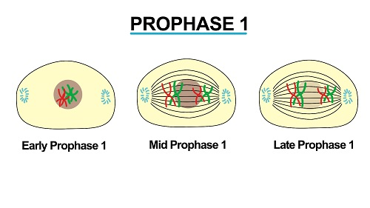

Early Prophase Mid-Prophase Late Prophase

*Metaphase*

Events during metaphase occur as follows:

* Formation of spindle fibers is complete
* Chromatids move to the equator of the spindle
* The centromere of each chromatid become attached to a spindle fiber

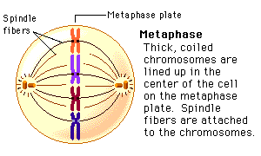

*Anaphase*

Events of anaphase stage are as follows:

* The centromere splits and the sister chromatids separate from each other. Each one of them now being referred to as ***chromosome.***
* Chromosomes begin to move towards the opposite poles of the cell by contraction of spindle fibers which join centromere to the centrioles

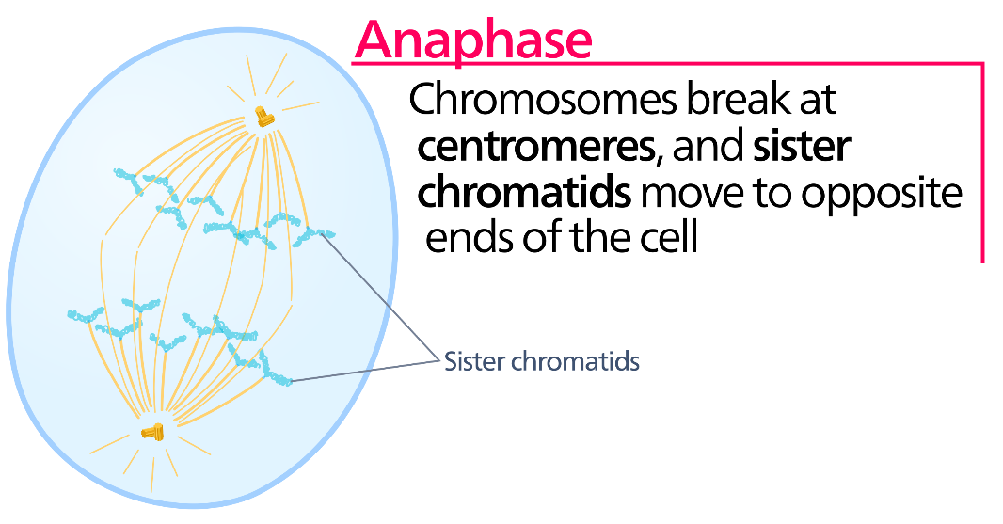

*Telophase*

Events during Telophase are:

* Chromosomes lengthen and become distinct
* The spindle fiber disappear
* Nuclear membrane forms around each set of chromosomes
* The cell constricts across the middle and divides into two.
* The two daughter cells formed each has diploid number of chromosomes

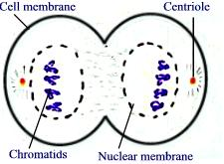

Telophase is immediately followed by ***cytokinesis.*** This is the division of cytoplasm whereby the cytoplasm pinches at the middle of the cell until two distinct daughter cells are formed.

In plant cells, a delicate membrane called ***cell plate*** start to form at the middle of the cell. Finally, a new cell wall forms on the either side of the plant.

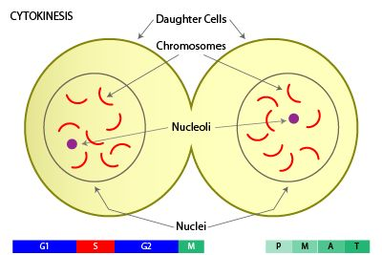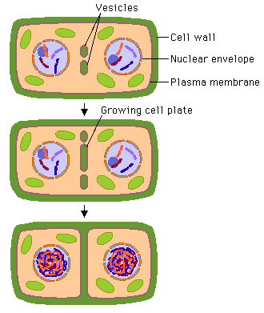

*Significance of Mitosis*

* It ensures genetic continuity as it maintains the same number and type of chromosomes in daughter cells as in the parent cell.
* It leads to increase in population growth in unicellular organisms
* It helps to replace worn out and damaged cells.
* It enables growth in multicellular organisms when followed by cell enlargement.
* It is the basis of asexual reproduction.

*Similarities between Mitosis and Meiosis*

* Both involves the process of nucleus/cell division
* Both involves chromosomes
* Similar changes occur in prophase, metaphase, anaphase and Telophase
* In both cases, DNA replication takes place
* Both occurs in living cells

*Differences between Mitosis and Meiosis*

|  |  |
| --- | --- |
| Mitosis | Meiosis |
| * Occurs in somatic cells | * Occurs in sex cells |
| * The number of chromosomes is retained constant in daughter cells as in parent cells | * The number of chromosomes in daughter cells is half the number of chromosomes in mother cells |
| * No crossing over | * There is crossing over |
| * No variations because daughter cells are the same genetically as parent cells | * There is variations because daughter cells are not the same genetically as parent cells |
| * Take place in one phase to complete division | * Take place in two phases to complete division. That is, meiosis I and II |
| * Two daughter cells are formed | * Four daughter cells are formed |
| * New cells do not fuse to form zygote | * New cells produced fuse to form zygote |

***Growth and Development in Flowering Plants***

In most flowering plants, growth starts when the seed begins to germinate.

*Germination* is the process by which a seed develops into a seedling. *Seedling* is a young plant.

*Structure of a Seed*

Seed develops from the ovules. The ovules are surrounded by the ovary which later develop into a fruit after fertilization.

After pollination, a *zygote* is formed. The embryo differentiate into an embryonic shoot called ***plumule*** and embryonic root called ***radicle***. The embryo also differentiate into seed-leaves known as ***cotyledons***.

The plumule is connected to the cotyledon, a tissue that stores food needed during germination.

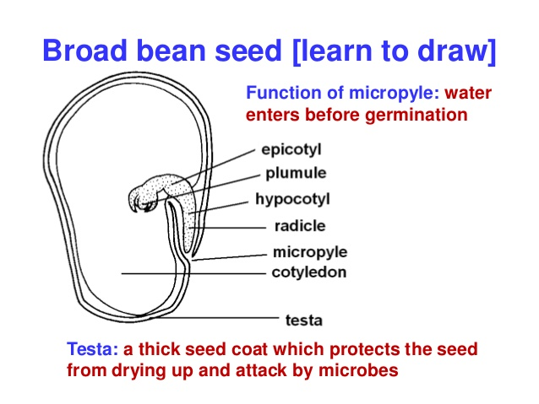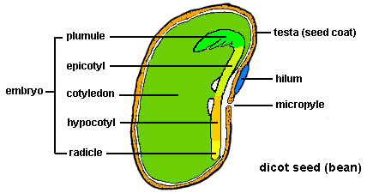

***Longitudinal Section of a Dicot Seed***

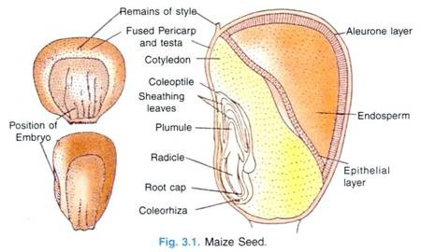

Point of attachment to the cob

***External and Internal Structure of a Monocot Seed (maize grain)***

* ***Testa*** is thick protective outer covering of a seed which protects the seed from drying up and attack by microbes. It is also known as the seed coat.
* ***Micropyle*** is a tiny hole in the testa opposite to the tip of the radicle. It allows water to get into the embryo before germination.
* ***Radicle*** is the embryonic part which grows and develop into the root system of the plant.
* ***Plumule*** is the leaf part of embryo which develop into shoot.
* ***Hilum*** is a scar left by the stalk which attaches ovule to the ovary wall.
* ***Cotyledon*** is a seed-leaf which contain food reserves used during the early stages of seed germination. Food stored is mostly starch and protein.
* ***Epicotyl*** is the region of an embryo or seedling stem just above the cotyledon or just below the plumule
* ***Hypocotyl*** is the part of the stem of an embryo plant beneath the stalks of the cotyledons and just above the root or radicle.
* ***Coleoptile*** is the pointed protective sheath covering the emerging shoot (plumule) in monocots such as grasses.
* ***Coleorhiza*** is a closed hollow cylinder or sheath of leaf like tissue surrounding and protecting the radicle (young root) in monocot seedlings.
* ***Root cap*** is a section of tissue at the tip of a plant root (radicle) which protects the growing delicate root against physical damage.
* **Endosperm** is the tissue produced inside the seeds of most of the flowering plants following fertilization. It surrounds the embryo and provides nutrient in the form of starch, though it can also contain oils and protein. This can make endosperm a source of nutrients in the human diet.

*Germination Process*

* The seed absorbs water through the Micropyle and swells up.
* The swelling up of the inner tissue cause rapture of the softened testa.
* Water dissolves the food stored in the cotyledon/endosperm to release energy
* Radicle (embryonic root) is the first to emerge and grow downwards between soil particles.
* The tip of the radicle is protected by root cap. The root hair develop which create a surface area for absorption of water and mineral salts. Later the lateral roots develop anchoring the radicle firmly in the soil.
* Radicle elongates to push the cotyledons with its enclosed plumule above the ground
* The plumule (embryonic shoot) emerges upwards, forming first foliage leaves which will have chlorophyll that absorbs solar energy for photosynthesis.

***Conditions Necessary for Seed Germination***

These conditions are classified into two main categories which are:

1. External conditions/factors
2. Internal conditions/factors

*External Factors or Conditions Necessary for Seed Germination*

1. Water

* Water is absorbed by the seed through the Micropyle
* It soften testa so that it can rapture/burst easily do that the radicle and plumule can emerge easily.
* Water causes the seed to swell and dissolve the stored food substances so as to simplify its digestion into simple soluble form for the growing of the embryo.
* It is required by the enzymes in the seed which start to digest the stored food into soluble form and speed up the rate of respiration.
* Water acts as a transport medium in the seed.

1. Oxygen

* It diffuses into the seed through the Micropyle but when the testa raptures it diffuses directly to the tissues.
* It is used during respiration which produces energy for processes like cell division and transport of food to the growing parts.

1. Suitable/Optimum Temperature

* Optimum/suitable temperature is needed to activate the enzymes which catalyzes the hydrolysis of the stored food substances in the seed to provide energy for germination.
* Enzymes are most active at optimum temperature. At low temperature enzymes are inactive while at very high temperature enzymes are denatured/destroyed.

*Internal Factors/Conditions Necessary for Seed Germination*

1. Enzymes

* Enzymes are important for hydrolysis of stored food substances. E.g. diastase enzymes converts insoluble starch to soluble form.
* Respiration requires a series of enzymes

1. Hormones

* These act as growth stimulators. E.g. Auxins.

1. Seed Viability

* Seed viability refers to the ability of the seed to germinate provided all other conditions are kept constant. Only alive and healthy seeds with mature embryo germinates.
* Seeds that have stayed for very long time lose their viability (some)

*Changes Occurring During Seed Germination*

1. Physical changes

* The seed absorbs water through Micropyle and swells up
* The testa/seed coat burst.
* The radicle emerges.
* The radicle continues to elongate and give rise to many seed roots
* The radicle elongates and pushes the seed out of the ground
* The seed coat is discarded and the two cotyledon open out and begin to photosynthesize.
* The plumule emerges and produces the first true leaves.
* At this stage the young plant is called is called ***seedling***.

1. Chemical changes

As the seed absorbs water the food stored undergo changes. They are hydrolyzed into soluble food.

Enzymes in a stored food include:

* Diastase –catalyzes the hydrolysis of starch into simple sugar
* Lipase –catalyzes the digestion of lipids into fatty acid and glycerol
* Proteases –catalyzes the digestion of protein to amino acid.
* During germination a lot of energy is required. The stored food materials are oxidized to release energy needed for germination
* As the seed germinate, its weight decreases until the seedling is capable of photosynthesizing. The germinated seed decreases in weight because the stored food is being used for growth of the seedling.

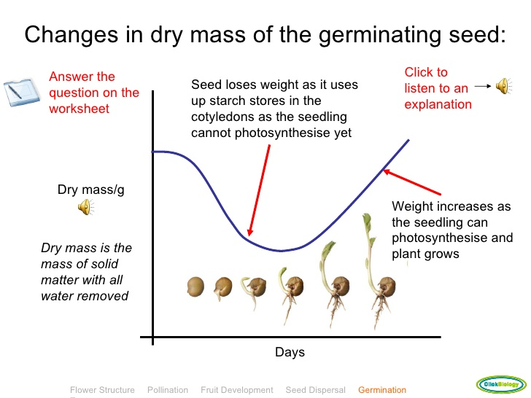

*Variation of Dry Mass of a Germinating Seed*

***Types of Germination***

There are two types of germination. These are

1. Epigeal seed germination
2. Hypogeal seed germination

*Epigeal Seed Germination*

This is the type of seed germination whereby the cotyledon of the seed is brought above the ground. This occurs in dicot plants like beans, cotton and ground nuts.

In Epigeal seed germination the hypocotyl carries cotyledon and plumule above the ground. Hypocotyl is part of the seedling below the cotyledon.

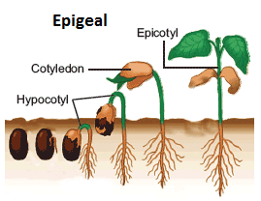

*Epigeal Seed Germination in a Dicot Seed*

*Hypogeal Seed Germination*

This is the type of seed germination whereby the cotyledon of the seed remains below the ground. It occurs in monocot plants like maize, millet and wheat.

In hypogeal seed germination, epicotyl carries the plumule to the ground. Epicotyl is a part of the seedling above the cotyledon.

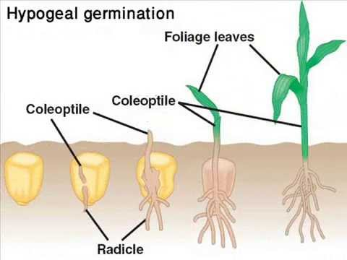

*Hypogeal Seed Germination in a Monocot Seed*

*Differences between Epigeal and Hypogeal Seed Germination*

|  |  |
| --- | --- |
| Epigeal Seed Germination | Hypogeal Seed Germination |
| * The cotyledon is brought above the ground | * The cotyledons remain below the ground |
| * Occurs mostly in dicot seeds | * Occurs mostly in monocot seeds |
| * Plumule and cotyledons are carried by hypocotyl | * Only plumule is carried out by epicotyl |
| * Cotyledons can photosynthesize | * Cotyledons can only store food |
| * Hypocotyl elongates first before epicotyl | * Epicotyl elongates first before hypocotyl |

***Seed Viability***

Seed viability is the ability of seeds to germinate and grow into adult plants

*Factors Affecting Seed Viability*

1. ***Seed maturity***. A seed is more viable if it is fully mature. A seed which is not mature cannot germinate.
2. ***Nature of the testa***. A seed having too thin testa becomes dehydrated before it germinates. This kills the seed. Also a testa which is too thick prevents entry of water into the seed. If no water enters the seed, germination cannot take place.
3. ***Storage conditions***. Storing seeds in a place that is too cold or too hot kills the embryo. Most seeds are well stored at room temperature of about 250*C*.
4. ***Temperature and moisture***. Seeds germinate at specific (optimum) temperature and moisture conditions. Under too dry conditions the seeds will not germinate. On the other hand, the seed do not germinate if temperature is too low.
5. ***Food store***. Adequate food stores are marked by big cotyledon or food storing tissue called endosperm. If a seed does not have adequate food stores, there will be no germination, and if germination starts, the seedling dies before it has fully germinated.
6. ***Light intensity***. Light is very important for the growth of a young seedling since it enables photosynthesis by foliage leaves and the green cotyledons.

***Seed Dormancy***

* Seed dormancy is a state in which **seeds** fail to germinate even under environmental conditions normally favorable for germination.
* During seed dormancy, the metabolism activities are usually very low but sufficient to help the seed cells survive.
* Some seeds will not germinate immediately after harvest even if they are supplied with suitable conditions.
* The seed must pass a dormant period lasting for weeks, months and even years depending on the type of a seed before they can germinate.
* Other seeds can germinate immediately after being shade from the parent plant.

*Importance of Seed Dormancy*

* It adds survival value of the plant seeds. That is, it ensures that not all seeds germinate at the same time. This is very important especially during prolonged drought conditions. If all seeds germinate at the same time in such condition, all seedlings would perish.
* Seed dormancy help an organism to withstand unfavorable conditions such as extreme cold, drought, shortage of water, etc.
* It allows time for dispersal of seeds by agents such as water and wind
* Temporary dormancy which is helpful for their harvesting, dry storage and as a source of food. In the absence of dormancy these grains were likely to germinate in the field and experience unfavorable conditions.

*Causes of Seed Dormancy*

* Immature embryo
* Hard (impermeable) seed coat/testa
* Presence of growth inhibitors
* After-ripening
* Food and water availability
* Climatic conditions
* Lack of enough oxygen

*Ways of Breaking Seed Dormancy*

* Removal of hard/impermeable testa by methods such as use of fire, rubbing the seed with sand, etc.
* Treating the seed with chemicals such as acids
* Provide the seed with enough air/oxygen
* Provide the seed with suitable/optimum temperature
* Ensure seed embryo is mature enough to germinate

***Primary and Secondary Growth***

***Primary growth*** is the increase in length of the shoots and roots. It is brought about by cell division, cell elongation and cell differentiation in the shoot and root apices.

***Secondary growth*** is the increase in thickness (girth) of wood, stem and root. It is brought about by cell division, cell expansion and cell differentiation in the intercalary cambium between the xylem and phloem of the vascular cambium.

***Note:***

***Apical Dominance*** is the inhibition of the development of the lateral bud by the terminal bud. This is because apical bud (terminal bud) contains high concentration of the growth hormone called Auxins. E.g. (IAA).

***Differences between in Animals and Plants***

|  |  |
| --- | --- |
| Growth in Animals | Growth in Plants |
| * It is diffused. That is, it takes place throughout the body | * It is localized. That is, it takes place in specific regions of the body called ***meristems*** |
| * Broken parts such as limbs cannot be whole regenerated | Broken parts such as branches can be regenerated |
| * Growth takes place for definite periods before maturity | * Growth continues throughout the life of the plant |
| * Growth does not involve increase in the number of parts | * growth involves increases in the number of parts |
| * Each species has a distinct season for growth | * Growth take place during definite seasons |
| * The young one are identical to adults except in the body size and sexual maturity | * A seedling does not resemble an adult plant |

***Plant Development and Activity of Meristem***

In plants, growth and development occurs in certain regions called ***Meristems.*** The main meristems are located at the tip of roots and shoots and they are called ***Apical Meristems.***

***Meristem*** is a group of plant tissue usually made up of small cells capable of dividing indefinitely and giving rise to similar cells. ***OR*** is a group of cells/tissues that have the ability to divide rapidly by mitosis to form new cells.

*Types of Meristems*

1. ***Apical meristem***. This is a type of meristem which occurs at the tip of shoots and roots of plants. This causes growth in length of roots and stems called primary growth.
2. ***Lateral meristem***. This is the type of meristem which occur in the vascular cambium. This causes growth in girth of shoots and roots called secondary growth.
3. ***Intercalary meristem***. This is the type of meristem which occurs in the region of permanent tissue. E.g. the base of the leaves in many monocotyledonous plants.

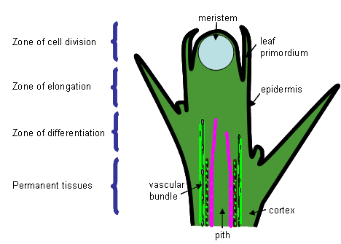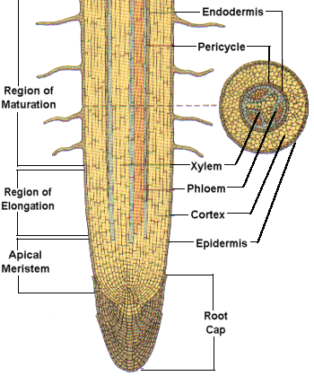

*A B*

*Longitudinal Section of Dicot shoot apical meristem (A) and Longitudinal (with cross-section) of Dicot root apical meristem (B)*

***Growth Curve***

Some of the criteria used to measure growth includes height, weight and cell number measured at a given time.

A growth curve is drawn in heights, weight and cell number against time. During growth period, growth rate is not the same.

*S-Shaped Growth Curve*

I

IV

II

III

Time

Growth

Rate

This graph is known as *sigmoid curve*. The curve is called sigmoid curve because it resemble the Greek letter sigma (δ). Ti has four phases. These are:

1. The lag phase
2. The log/rapid/exponential phase
3. Stationary phase
4. Decline phase

***Lag Phase****:* this is the phase where there is little growth or slight decrease in growth. E.g. in flowering plants, there is loss of dry weight during seed germination. Growth rate is slow at this phase because:

* The number of dividing cells is small.
* The cells of organisms are not yet adjusted to the environment.
* This is the time of rapid cell division but very little expansion

***Log/rapid/exponential Phase****:* this is the stage where there is maximum rate of growth. Growth is rapid because:

* There is large number of dividing cells and expanding cells
* The rate of cell increase is greater than the rate of cell increase
* The cells or organisms have adjusted to the environment hence food, space, air, water, light, etc. are not limiting.

***Stationary Phase****:* this is the stage where growth ceases (stops) and the parameters under consideration remains constant. The rate of cells increase is equal to the rate of cells death. In micro-organisms, the number of individuals dying is approximately equal to the number of individuals formed.

***Decline phase:*** this is the stage at which the maximum peak is reached and growth starts to decline. This can be because:

* The rate of cell death is more than the rate of cell increase
* Most cells have fully differentiated and hence can’t undergo most differentiation.

*Intermittent Growth Curve*

Intermittent growth is the type of growth that occurs in stages. E.g. in arthropods. These series of stages show sudden changes in weight or lenth. Each stage is called ***Instar***. All arthropods have an exoskeleton made up of hard chitinous cuticle which prevent growth of the body as it hardens. Growth occurs rapidly again after ecdysis/moulting.

*Ecdysis* is the periodical shade off of the exoskeleton to allow growth in arthropods.

The graph for intermittent growth is as shown below:

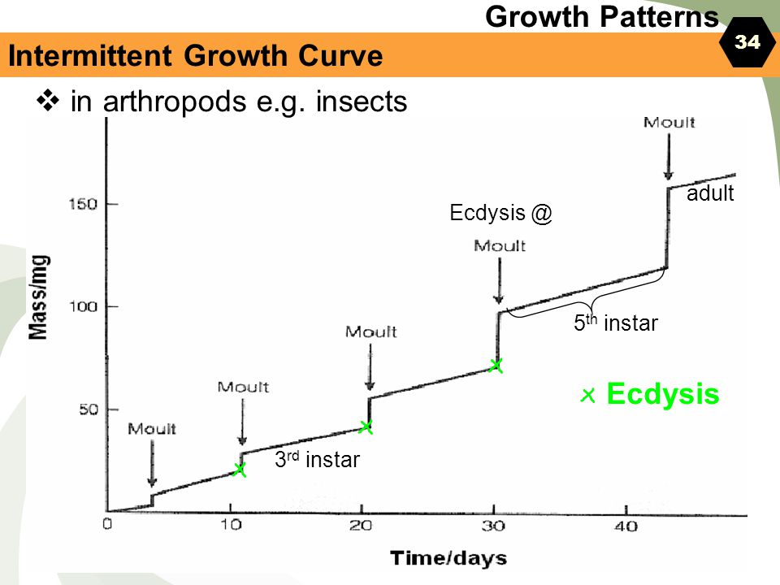

*Indeterminate Growth Curve*

Terrestrial perennial plants exhibits wave curve. This is because such plants are exposed to dry and wet seasons during their life. Under wet seasons growth is rapid, while under dry season growth is low. Since the wet and dry season alternate. Rapid growth will also be alternating with low rate of growth.

Growth

Rate

Time

***Metamorphosis***

This refers to the series of changes in the body shape and structure by which an egg of an animal change into an adult organism. E.g. insect, amphibians, etc.

***Types of Metamorphosis***

There are two main types of metamorphosis. These are:

1. Complete metamorphosis. E.g. Butterflies, houseflies, mosquitoes, beetles, etc.
2. Incomplete metamorphosis. E.g. cockroaches, grasshoppers, frog, etc.

***Complete Metamorphosis***: the egg hatches into larva and pupa then adult. Pupa and larva are completely different in form and behavior from adult.

*Larva* stage is the feeding and growing stage after which is transformed into a pupa. The larva of butterfly is called ***caterpillar.*** The larva of housefly is called ***maggot***.

*Pupa* is outwardly dormant. It is inactive neither moving nor feeding. Changes take place within its body giving rise eventually to the adult or imago.

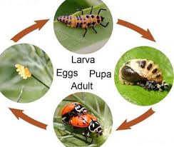

***Incomplete Metamorphosis***: in this case, the egg hatches into nymph. The nymph resembles the adult in many ways. It therefore undergo very few changes to attain the adult body form.

*Nymph* differs from the adult in that it has no wings and it is smaller in size.

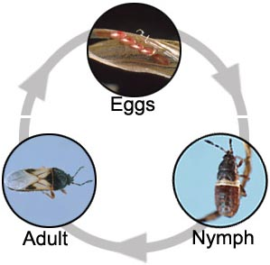

*Metamorphosis in Frog:* the egg hatches to tadpole. The tadpole then develops into adult and then the cycle starts again.

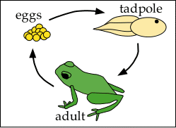

*Differences between Tadpole and Adult Frog*

|  |  |
| --- | --- |
| Adult Frog | Tadpole |
| Has four legs | Has no legs |
| Has no gills | Has gills |
| Has no tail | Has tail |
| Has no operculum | Has an operculum |

***Stages of Postnatal Growth in Human***

Postnatal growth is the growth that takes place after birth. It is categorized into four stages. These are:

1. Childhood
2. Adolescent
3. Adulthood
4. Senescence/old age

*Note:* Development in humans involve increase in ability to perform various skills both physical and intellectual.

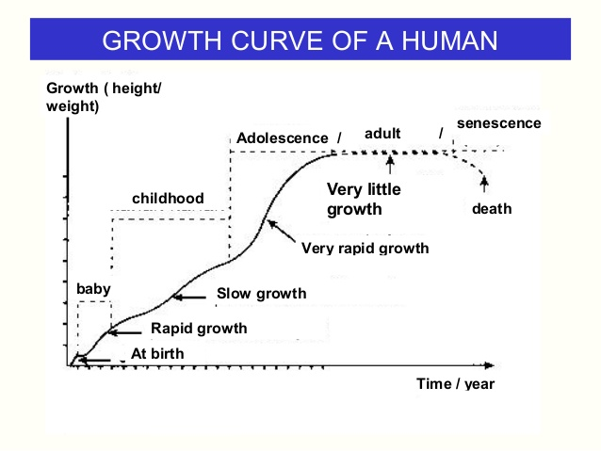

*Growth Curve in Humans*

*Childhood Stage (1-10 years)*

Is the stage between birth and sexual maturity **OR** is the period of rapid growth because cells divide rapidly. It is divided into:

* Infancy (baby) stage (0-3 year). It is the period of rapid growth.
* Juvenile stage (4-10 years). Here there is slow rate of growth.

*Adolescence Stage (11-18 years)*

This is a period of rapid growth that takes place between childhood and adulthood.

* There is sex maturity
* It is accompanied by physical and emotional changes that occurs in both boys and girls to prepare their bodies for parenthood
* It occurs at the ages of 11-13 years for girls and 12-14 years for boys.

*Adulthood Stage (19-45 years)*

This is the stage where there is very little growth. Adults are physically and psychologically mature to make families.

*Senescence/Old Age Stage (46-55 years)*

This is the stage of senescence and begins at age of between 45 and 55 years OR simply after menopause in woman. Men tend to diminish their sexual activity but they are not actually sterile.

***Psychological and Behavioral Changes Associated with Growth and Development***

The changes that occur may differ slightly among individuals and societies depending on factors such as

* Diet
* Social environment
* Eating habit
* Heredity
* Sex

*Behavior Changes during Adolescence*

* Refusing to listen to their parents and supervisors
* They rebel against parental orders
* Peer groups are formed and they may play great role in expressing the characters of the youth.
* Boys and girls become conscious of themselves as boys and girls. Boys would like to talk to girls and girls would like to talk to boys (interested in opposite sex)

*Psychological Changes during Adolescence*

Psychological changes are noticeable symptoms of internal changes that may cause emotional and intellectual changes among youths.

Very often the emotional changes are not easily noticed except when there are external signs like crying or laughing. The changes are as follows:

* Youth develop positive social attitudes such as to have love sympathy for others.
* Making decision about major things in their lives.
* Making some unnecessary argument with parents and elders
* They identify themselves as much more important on the social stage
* They are seeking for independence

*Psychological Changes during Old Age*

* Loss of memory due to death of brain cells
* Power of concentration becomes low.

*Physiological Changes during Old Age*

* Loss of hair of the head
* Wrinkling of the skin
* Lowered resistance to diseases
* Weakening of bones
* Heart muscles and arteries loose elasticity which later decreases rate of blood flow
* Difficulty in breathing
* Degeneration of nervous system and as a result hearing and vision becomes less cute, failing of eye sight and poor sense of taste and smell.
* Loss of muscular strength and joint stiffness

***Factors Affecting the Rate of Physical Deterioration of Human Body***

1. Poor nutrition

* Excess take of food leads to obesity which shortens individual’s life span.
* Excessive fats burdens the heart and may cause coronary thrombosis
* Lack of enough food lead to poor growth of the body

1. Diseases and infection

* Pathogens (parasites) deprive our bodies of nutrients and oxygen, damages the tissue and produce toxic substances that accelerate deterioration

1. Poverty

* Poor families are not able to acquire better medical services and education. This leads to poor health which quickens ageing

1. Emotional disturbances

* Such as stress, frustration, tension and anxiety shorten the life span of an individual

1. Some behavior such as alcoholism and drug abuse
2. Lack of exercise

***The Limiting Factors that Regulate Growth in Individual and Population***

1. *Food and water availability*. In the area where food and water are adequate, competition is reduced and population increases. If there is no food and water for individuals, population decreases
2. *Light intensity.* Light is important for green plants to make their own food. Plant compete for light with each other in the area of dense vegetation.
3. *Space.* Organisms compete for breeding sites and shelter. Harsh environment and lack of space cause accumulation of waste products which may lead to eruption of diseases or death of the organisms.
4. *Accumulation of toxic wastes.* High accumulation of poisonous substances such as carbon dioxide, carbon monoxide, sulphur dioxide and nitrogen wastes (ammonia) affects the life of individual and hence the general population
5. *Diseases.* Overcrowding result in the rapid spread of diseases within a population and outbreak of epidemic diseases can wipe the whole population out. E.g. Ebola.
6. *Predators and Parasites.* Predators kills another organism for food. A parasite is an organism that obtain its nutrients from another living organism. An increase in number of number of predators and parasites leads to death of prey and host organisms.
7. *Oxygen and carbon dioxide concentration.* These are respiratory gases. Oxygen is required by all living organisms for respiration process to produce energy. Carbon dioxide is required by plants as raw material or photosynthesis. Pollution off the environment will lead to deficiency of these gases.
8. *Climate.* Weather and climatic condition affects the size of population. Due to excessive heat in deserts, there is low population compared to tropical rainforests.

***Practical Work on Growth and Development***

***Experiment 1***

*Aim*

To find whether oxygen gas is necessary for germination

*Requirements/Resources*

Soaked seeds, cotton wool, flat bottomed flask, cork, water, pyrogallic acid and sodium hydroxide

*Procedures*

* Put some pyrogallic acid and sodium hydroxide solution in flask A
* Wrap few seeds in moist cotton wool
* Suspend the moist cotton wool from the cork inside the flask A by use of hooked wire
* Repeat the experiment for flask A in a flask B but without pyrogallic acid and sodium hydroxide. This is your control experiment
* Leave the set up for 5 days

***Revision Questions***

1. a. Differentiate growth from development.
   1. Of what importance is growth?
2. a. Plants exhibit localized growth while human being exhibit diffused growth. Distinguish the underlined terms.
   1. Distinguish between:
      1. Primary growth and secondary growth
      2. Allometric growth and isometric growth
3. a. What is seed germination?
   1. Briefly explain the internal factors and external factors necessary or seed germination to occur.
   2. Differentiate epigeal germination from hypogeal germination.
4. Briefly explain six (06) factors affecting the rate of deterioration of the human body.
5. a. Define mitosis
   1. What is the significance of mitosis?
   2. List down the stages of mitosis.
6. a. Distinguish between:
   * 1. radicle and plumule
     2. hypocotyl and epicotyl

b. Give the differences between *plant growth* and *animal growth*.

1. Draw a sketch graph to show:
   1. A typical growth curve of a bean plant as it develops from seed to maturity
   2. A typical growth curve of an insect.
2. a. What do you understand by the term meristem?
3. Name two types of meristems and their significance
4. Secondary growth is most common in dicots but very rare in monocots. Why?
5. a. Name five diseases against which children are immunized.
6. Give four advantages of breast feeding over bottle feeding.
7. Bottle milk can substitute breast milk. Give four (04) reasons for substitution.
8. Write an essay on seed dormancy using the following guideline:

* Meaning of seed dormancy
* Six causes of seed dormancy
* Six methods of breaking seed dormancy
* Two advantages and one disadvantage of seed dormancy

1. Study figures 1 and 2 below and answer the questions which follow:

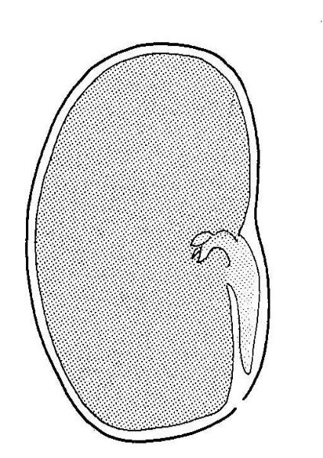 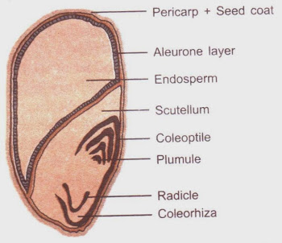

L

M

N

P

1

2

3

4

5

6

7

Figure 1 Figure 2

* 1. What does figure 1 represent?
  2. Name parts indicated by letters L to P
  3. What does figure 2 represent?
  4. Name parts indicated by numbers 1 to 7
  5. Give the letter of the part in figure 1 which is:
     1. The embryonic shoot
     2. The embryonic root
  6. Of what function is part P?

1. Study figure 3 below and answe the questions which follow:

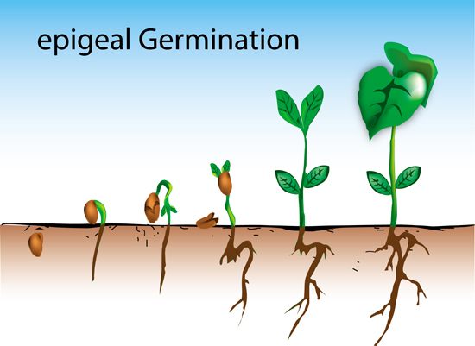

X

R

S

U

T

W

Y

Z

Figure 3

* + - 1. Give reason to suggest whether the figure exhibits epigeal or hypogeal seed germination
      2. Name parts R to Z in figure 3
      3. Name four (04) other plants which exhibit the type of germination you have named in (a) above.
      4. State function of part Z
      5. Give adaptation(s) of part Z to the function tou have stated in (d) above.

1. Study figure 4 and 5 below then answer the questions which follow:



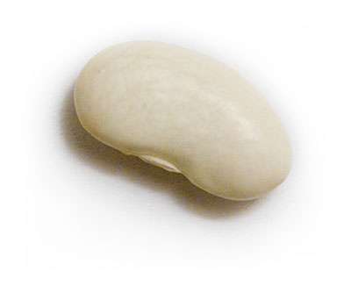

Figure 4 Figure 5

* 1. Give common names of the organism/part of the organism represented by figures 4 and 5
  2. Name the process through which figure 4 develops into figure 5
  3. Briefly explain three (03) external factors required by figure 4 to develpo into figure 5
  4. List down physical changes which occur in figure 4 to develop into figure 5

1. Figure 6 is an ordinary cell. Observe the figure carefully and answer the questions which follow.

P

Q

R

Figure 6

* 1. Name parts P, Q and R
  2. How many chromosomes are there altogether?
  3. How many pairs of homologous chromosomes are there?
  4. If this cell divides by mitosis, how many chromosomes will be in each daughter cell?
  5. If the cell divides by meiosis, how many chromosomes will be in each daughter cell?
  6. How many daughter cells will be formed if the cell divides by:
     1. Meiosis
     2. Mitosis

1. Study figures 7A and 7B below and answer the questions which follow:

5

4

2

3

1

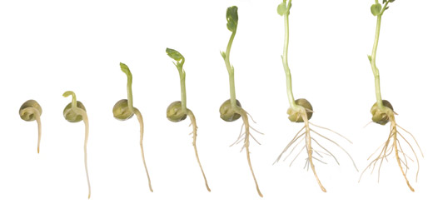

Ground

Figure 7A

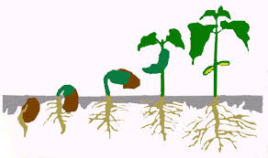

8

9

7

10

Figure 7B

* 1. Name the parts indicated by numbers 1 to 10
  2. What external conditions do you think possibly help the grain/seed to the developmental stage you are seeing
  3. Explain the role of each condition you have named in (b) above.

1. Study the process A and B in figure 8 and answer the accompanying questions below:

Nuclear membrane

PROCESS A

PROCESS B

Chromosomes

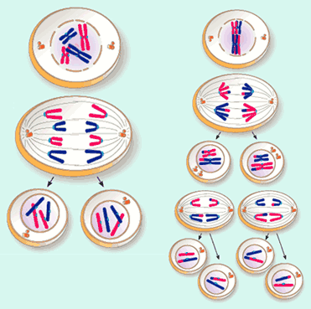

Figure 8

1. Name process A and B
2. Give the significance of process A
3. Give four (04) differences between process A and B
4. Hemed set up an experiment on a bean radicle as shown in figure 9 below:
5. a. What is the role of cotyledons and endosperms in seed during germination?

b. Give two functions of micropyle of a seed

c. Explain two internal factors and four external factors affecting growth in plants.

1. The graph below represents a growth curve of a certain plant as it develops from seed to maturity.

Time

Mass

* 1. Suggest common nsmes of two plants which exhibit such a growth curve
  2. What type of growth curve is shown by the graph?
  3. Giving reasons, explain why the plants named in 9(a) above must exhibit such a growth curve.

1. The diagram below represents a growth rate pattern of a certain group of animals. Study it carefully and answer the questions which follow:

Time

Growth

Rate

1. Name two groups of animals which exhibit such growth pattern
2. Why such animals exhibit such growth pattern?
3. What type of graph is represented by the above diagram?
4. With the help of diagrams, briefly state the events occurring at each stages of mitosis.